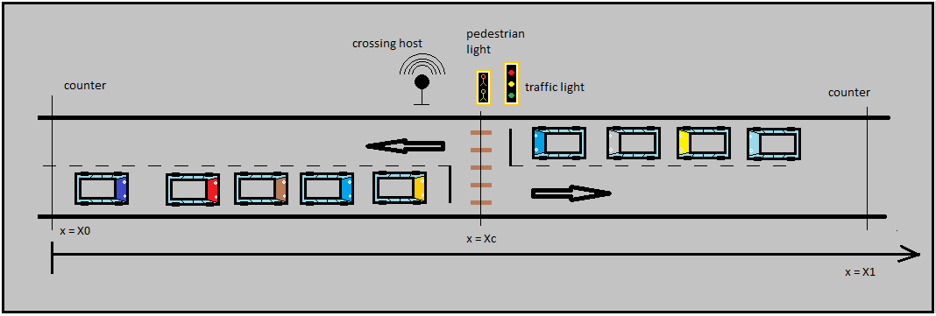
Objects on wifi :
- Scheduler
- Vehicles

Objects on Can :
- Scheduler (Crossing host)
- Traffic light
- Pedestrian light
- Counter
- Pedestrian button

Objects on GPS :
- Scheduler
- Vehicles
- SATELITE

Parameters:
- X0 : control distance

Process Modell Architecture
. . . . .
can bus
couter-1
counter-2
. . .
traffic light
Scheduler Cross-host
wifi
Pedestrian button
GPS
SATELITE

vehicle

vehicle

vehicle

vehicle

pedestrian light
reflector

1
2
3
A

1
2
3
B

1
2
3
C

D
4
5
6

Decision making vehicle
No care vehicle
Next vehicle
pass
stop
LEGENDA
Stop at light
Sensor-measure

Decision making process for a vehicle approaching to a traffic lamp.
CASE A
IF ((the Traffic-Light is RED) AND (Current-Vehicle is approaching OR at Traffic-Light))
{ if (bSubCase-1) Current-Vehicle PASS
Else if (bSubCase-2 OR bSubCase-3) Current-Vehicle HALT
}

bSubCase-1: Current-Vehicle is approaching AND sensor-measure > tolerance
bSubCase-2: Current-Vehicle is approaching AND sensor-measure <= tolerance
bSubCase-3: Current-Vehicle is at Traffic-Light

CASE B
IF ((the Traffic-Light is YELLOW) AND (Current-Vehicle is approaching OR at Traffic-Light))
{ if (bSubCase-1 OR bSubCase-3) Current-Vehicle PASS
Else if (bSubCase-2) Current-Vehicle HALT
}
bSubCase-1: Current-Vehicle is approaching AND sensor-measure > tolerance
bSubCase-2: Current-Vehicle is approaching AND sensor-measure <= tolerance
bSubCase-3: Current-Vehicle is at Traffic-Light

CASE C
IF ((the Traffic-Light is GREEN) AND (Current-Vehicle is approaching OR at Traffic-Light))
{ if (bSubCase-1 OR bSubCase-3) Current-Vehicle PASS
Else if (bSubCase-2) Current-Vehicle HALT
}
bSubCase-1: Current-Vehicle is approaching AND sensor-measure > tolerance
bSubCase-2: Current-Vehicle is approaching AND sensor-measure <= tolerance
bSubCase-3: Current-Vehicle is at Traffic-Light

CASE D
IF (the Current-Vehicle is after Traffic-Light)
{ if (bSubCase-4) Current-Vehicle PASS
Else if (bSubCase-5) Current-Vehicle HALT
}

bSubCase-4: sensor-measure > tolerance
bSubCase-5 sensor-measure <= tolerance

